**Week 5 –** [**Building a SOAP Service in Spring Boot**](https://docs.google.com/document/d/1li5Xi3w5-DwpSNjbb73_QYGFuk7DHmilq9mcJglsHoU/edit?usp=sharing)

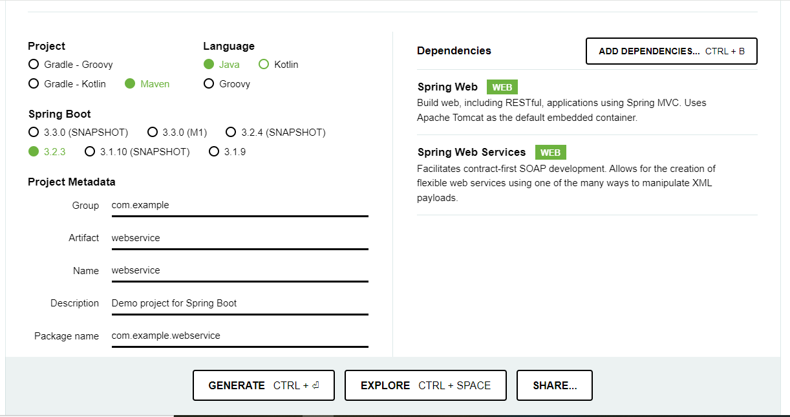

Figure 1: Spring boot from spring initializer

I have added the dependency into the pom.xml file manually.

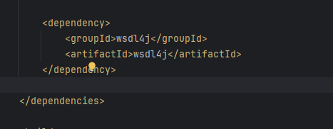

Figure 2: wsdl Dependency in pom.xml

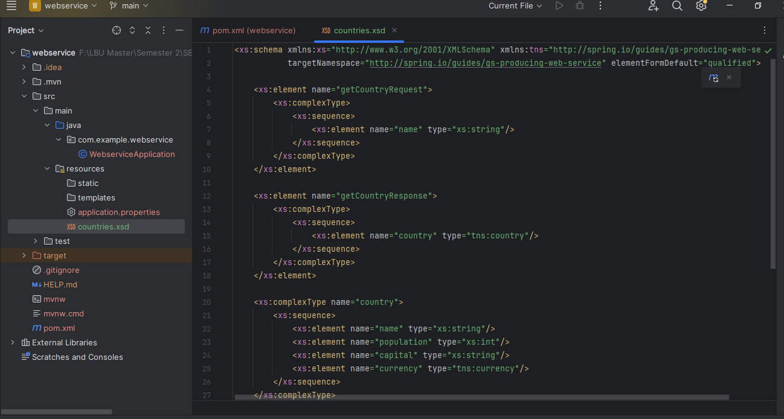

Figure 3: Countries.xsd file

Added the **Javax.annotation** and **javax.xml.bind** dependencies in pom.xml file.

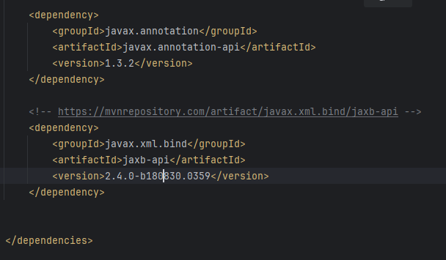

Figure 4: Javax dependencies

**Step 6: Country Repository**

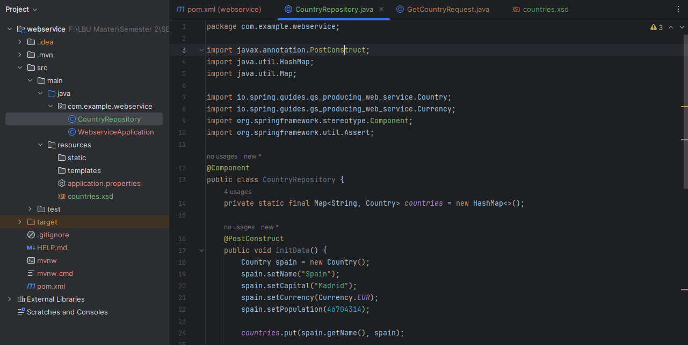

Figure 5: Country Repository Class

**Step 7: Country Service Endpoint**

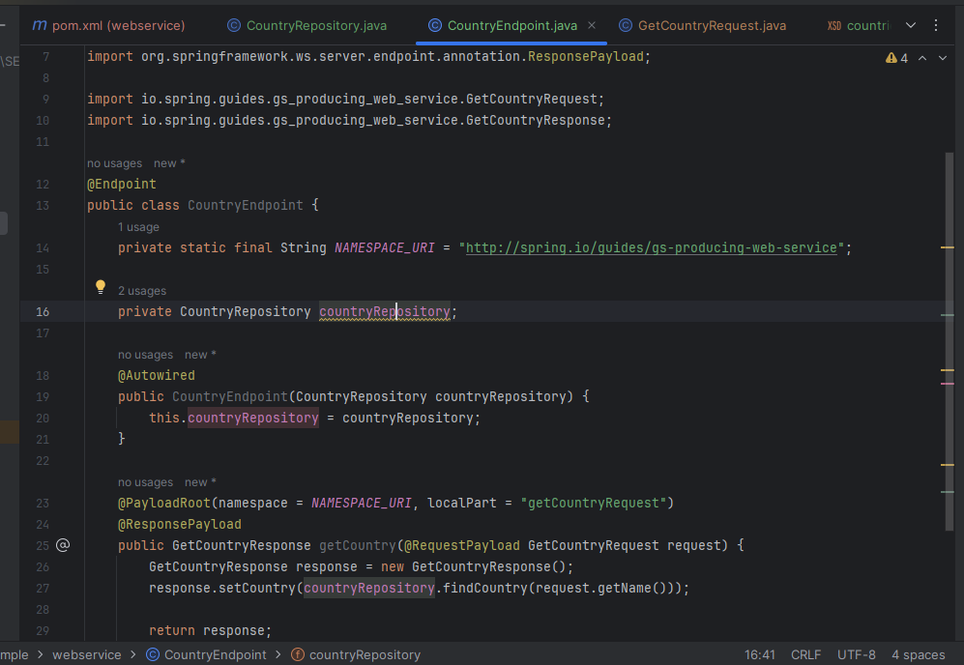

Figure 6: Country Service Endpoint

**Step 8: Web Service Bean**

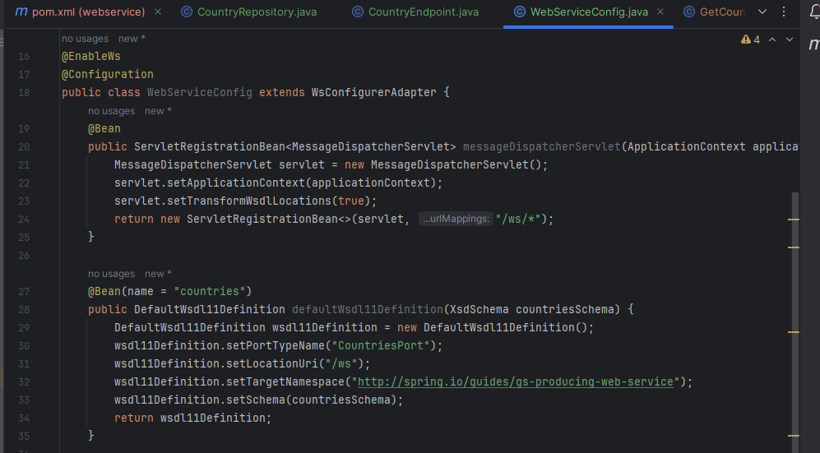

Figure 7: Web Service Bean

**Step 9: Running the Service**

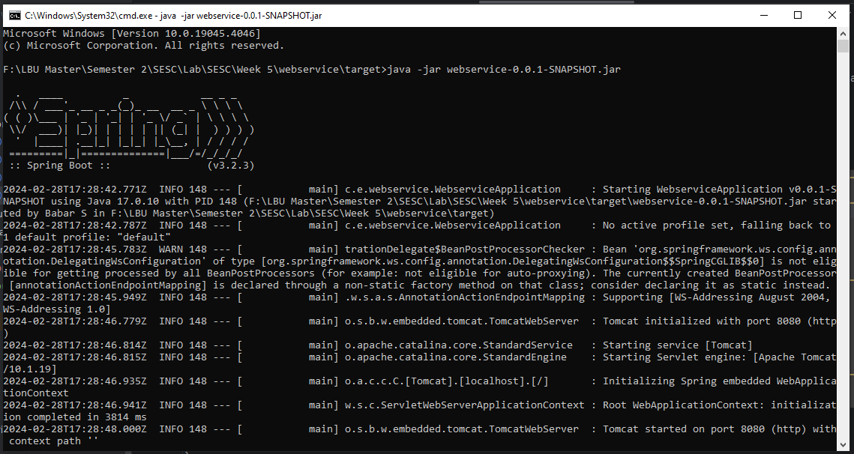

Figure 8: Running server using cmd

**Step 10: Examining the service**

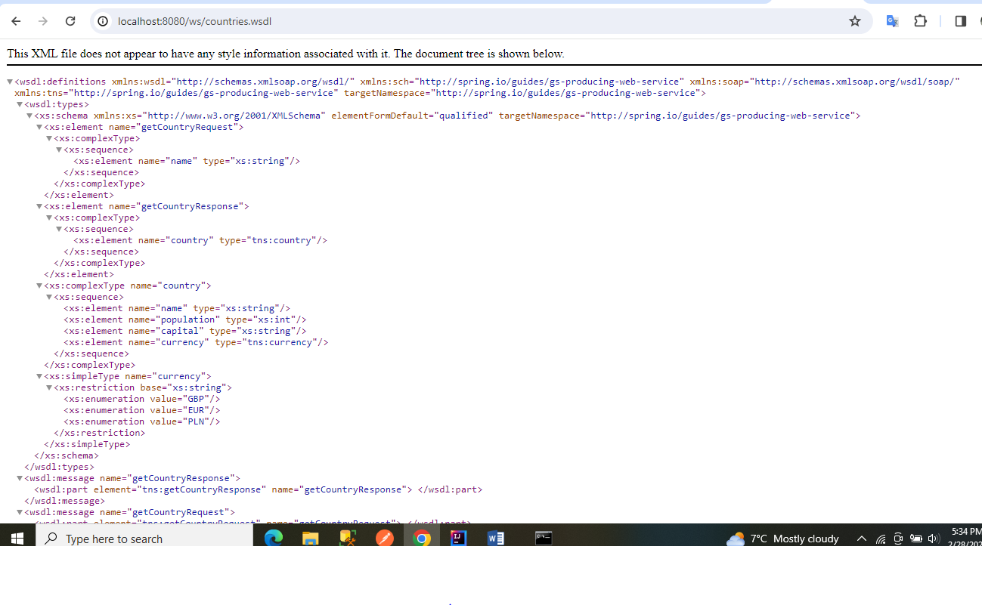

Figure 9: Service in browser